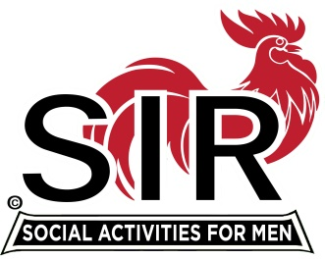
Las Trampas Branch 116
BEC Meeting Agenda
September 19th, 2022, 9:15 AM at Boundary Oak

The Mission of SIR is to enhance the lives of our members through fun activities, events and luncheons – while making friends for life.

9:15 am Call to order; Secretary, Paul Ramacciotti, confirm a quorum and Approval of Aug 23rd 2022 BEC meeting minutes
9:20 Standing Reports
- Treasurer – Al Satake – Financial Update
- Luncheon Report – Phil Goff
- Sept Boundary Estimated Count
    - Late cancellations after Thursday prior to Luncheon
    - Contacting late cancellations procedure
- Membership – Phil Goff
- RAMP Department Head Reports:
- Recruitment, Don Schroeder
- Activity Coordinator Alex Lutkus for Mike Ward
- Member Relations David Harris
- Publicity Fred Wachowicz
- Covid Compliance - Kevin Donahue (BA.5 and any related updates etc.)
  - State Policy Change

9:40 Little SIR Updates – Roger Craig
Speaker Update
Birthday Boys
9:50 Misc. Updates & New Business

- Christmas Party Dec 14th at Boundary Oaks
- October Luncheon and Vaccine Opportunity
- Boundary Oaks Branches, Area Branches, and Overlapping Opportunities
  - Contact Plan for Activity Sharing
  - Team for Assessing membership situation
- Volunteers Needed: Recruiting Assistants, Speaker Team Member, Member Relations Assistants

10:15 am Adjourn; For Lunch Preparations

